JENKINS -03
1. Create one Jenkins job using the below code and create three stages.
- stage1: Git clone to download the source code.
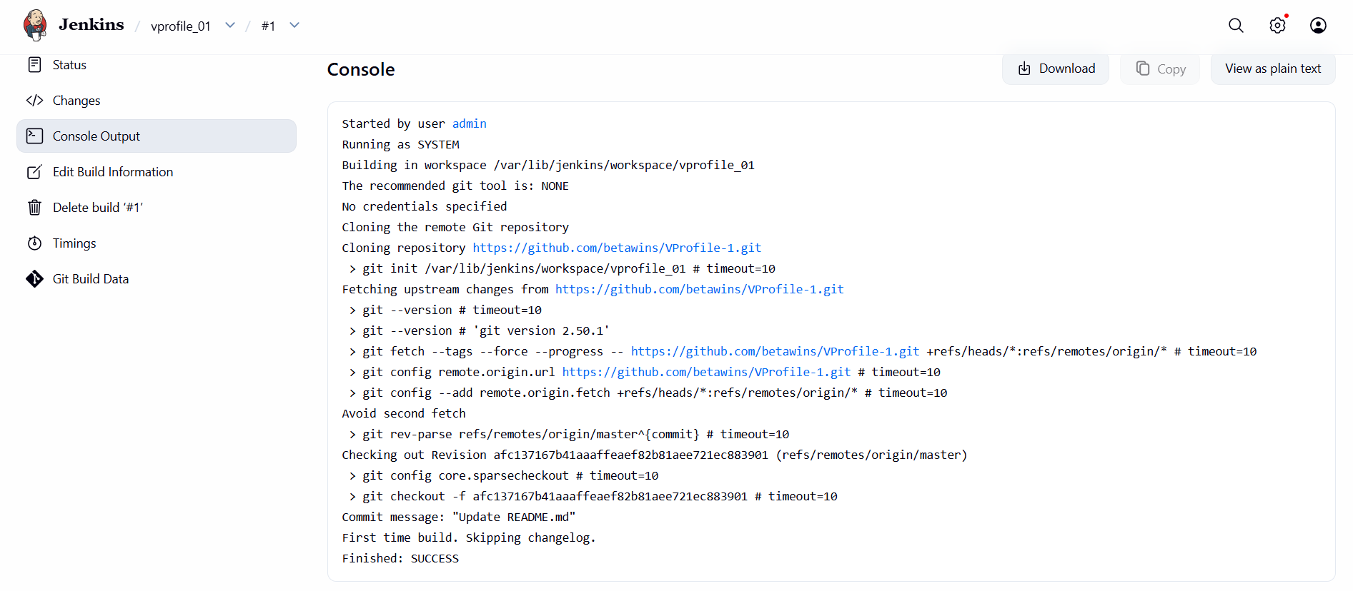
- stage2: Sonarqube Integration to check the quality of code.
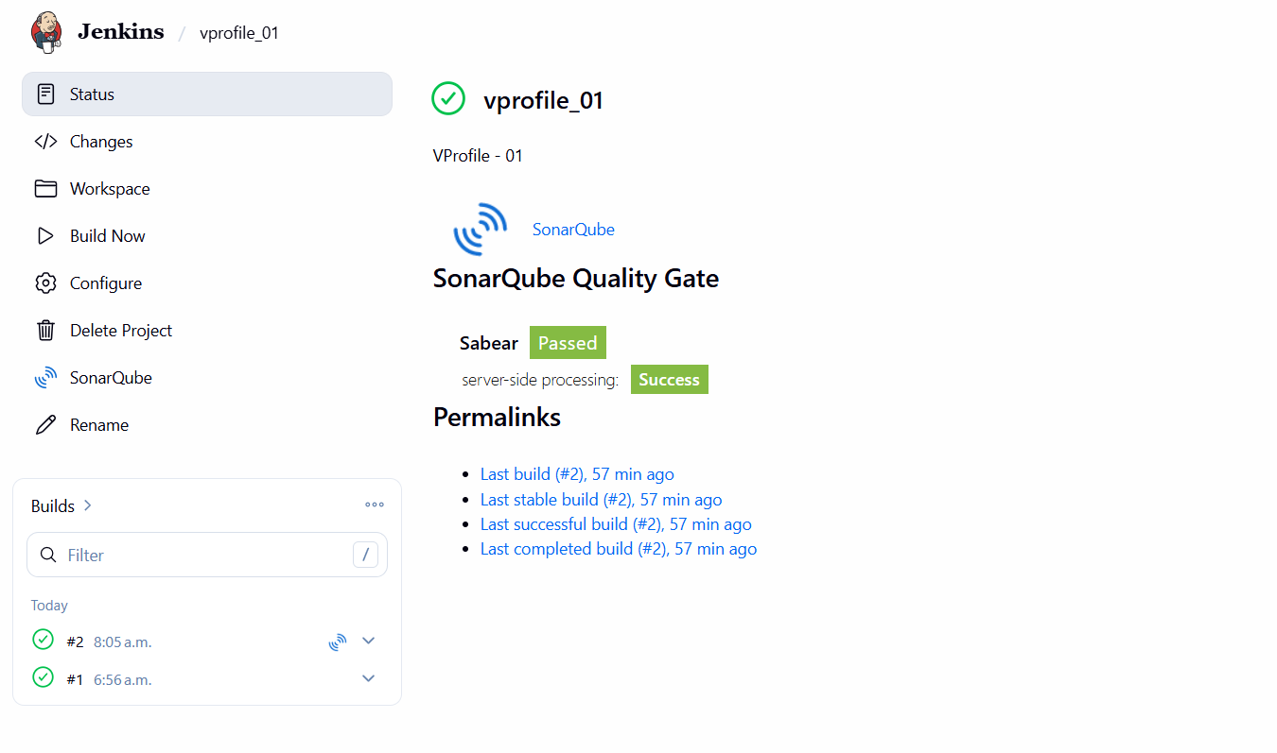
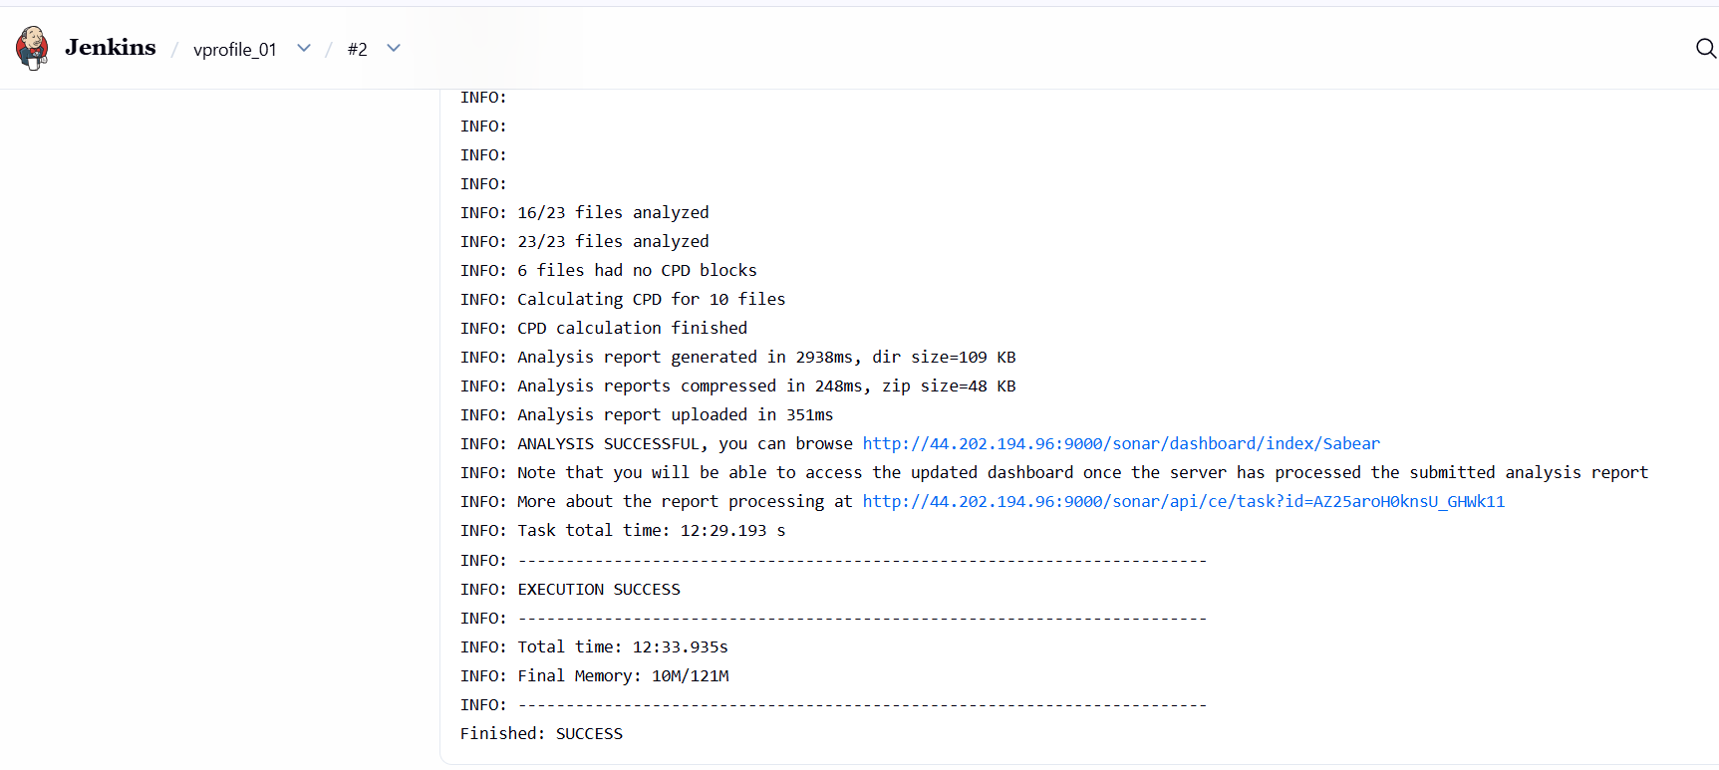
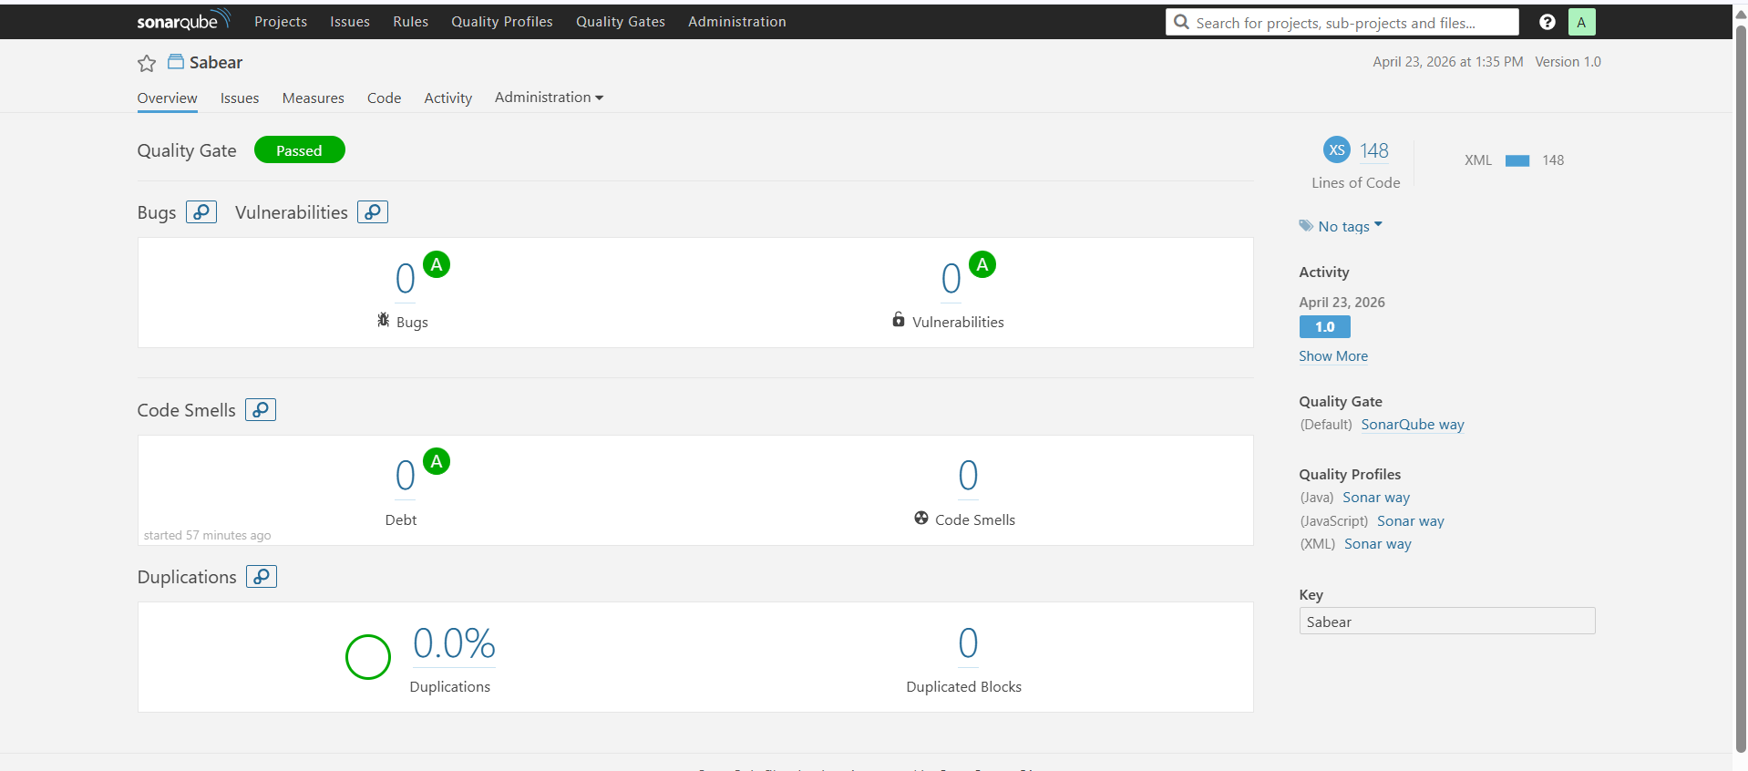
- stage3: Slack Integration to send the alerts to slack.
Source Code: https://github.com/betawins/VProfile-1.git
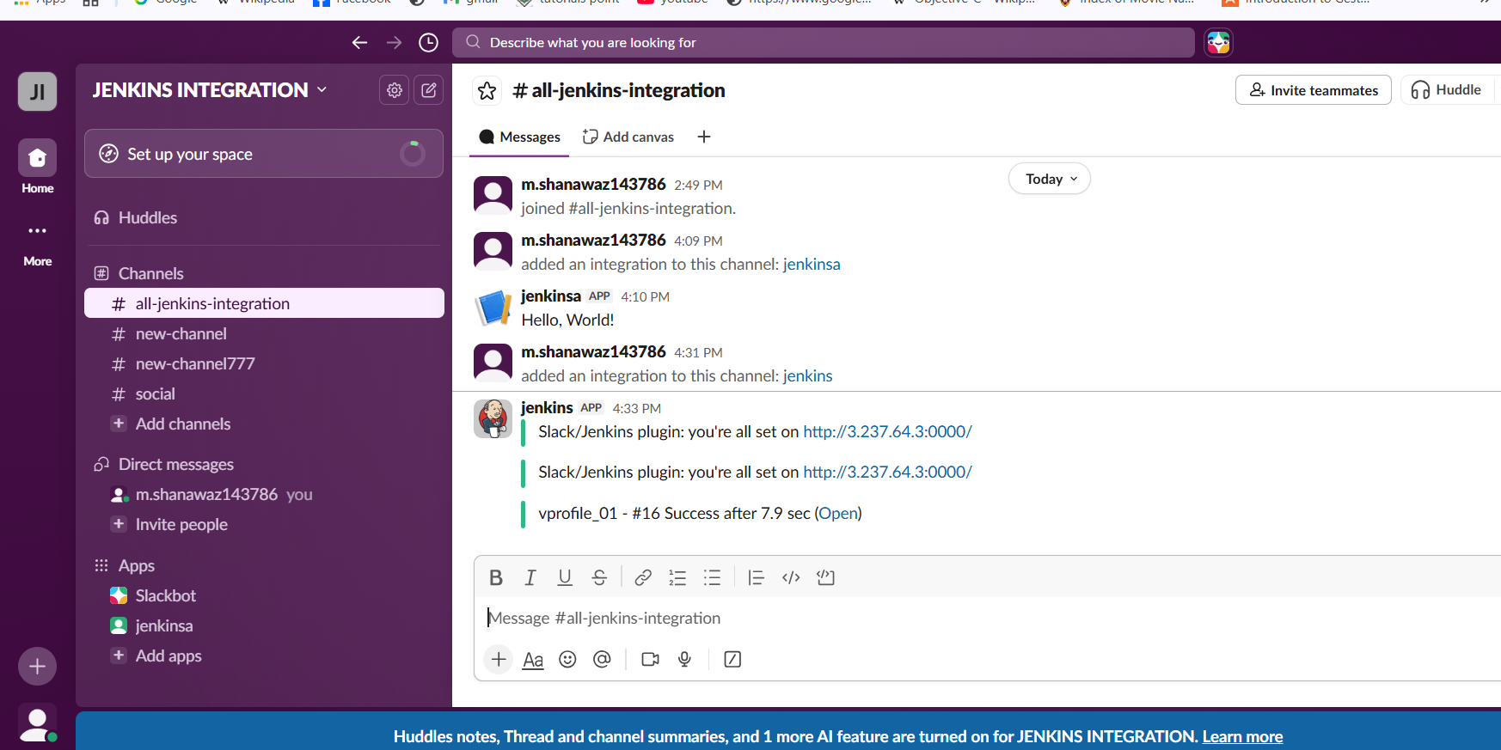
2. Create one Jenkins job using the below code and create three stages.
- stage1: Git clone to download the source code.
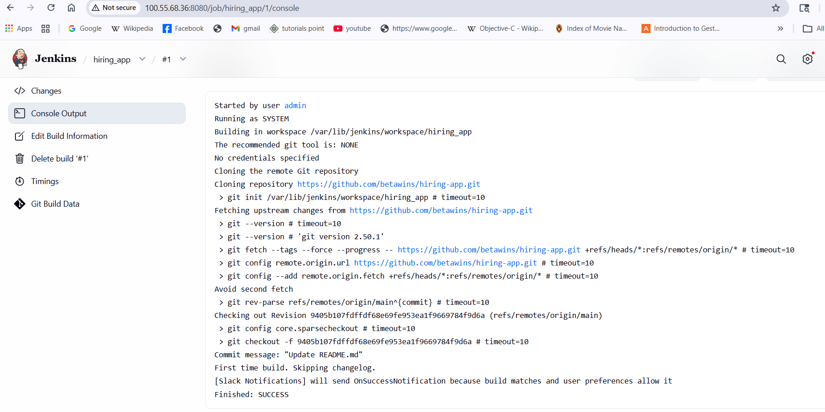

- stage2: Sonarqube Integration to check the quality of code.

- stage3: Slack Integration to send the alerts to slack.
Source Code: https://github.com/betawins/hiring-app.git
- Create a job in Jenkins
- Provide description and continue
- Provide the Git repo name.
- Add the details in analysis properties which available in repo
- Enable slack notifications and continue
- After saving the job was successfully created and will test
After restarting the ec2 instance we need to update some details and need to integrate with Jenkins so that generate a token in sonarqube and copy it
- Pate the token in Credentials in Jenkins and continue by clicking on save
- Also change the EXECUTE SHELL COMMANDS with new ip and new token
- After saving again click on build and continue by verifying at SONARQUBE
- Also slack was integrated in build steps so that we can verify the notification in slack also

